DIVINE SECONDARY SCHOOL KITALA

BEGINNING OF TERM TWO EXAMS

S.3 CHEMISTRY

TIME : 2 HOURS

NAME………………………………………………………………………….SIGN………………….

LIN…………………………………………………………………………………………..

INSTRUCTIONS TO SEMI CANDIDATES

ANSWER ALL ITEMS

1. Charcoal burning is one of the sources of income and the main source offuel in Uganda but recently charcoal burning has attracted a nationalconcern where the majority of people are against it.Explain the effects ofthis economic activityandhowit canbeprevented.

Support material

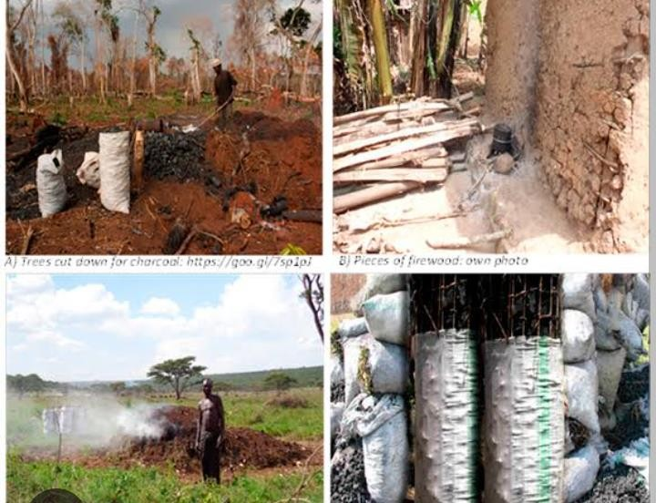

1. People have encroached wetlands in search of land for settlement andsetting up industries. This has caused major problems to the country andpromotedthegovernmenttocampaignagainstwetlandencroachment.

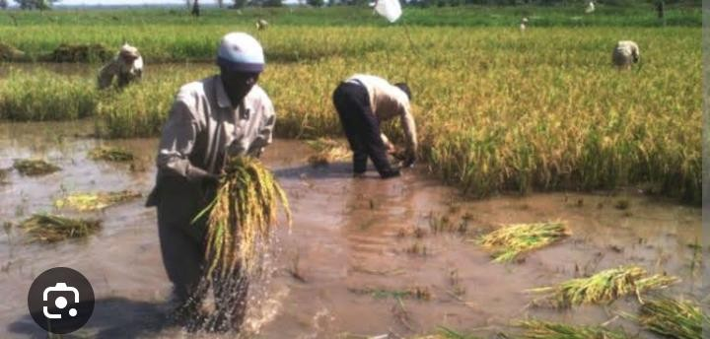

## Task

As a learner of chemistry, write a speech explaining to your communitywhythe governmentis againstwetland encroachment.

1. Large deposits of oil have been discovered in Lake Albert near Hoima city.Crudeoilcontainsavarietyofdifferentcompoundsbutwithsimilarstructure.The simplest of these compounds is methane of molecular formula CH4 andmanyothers.

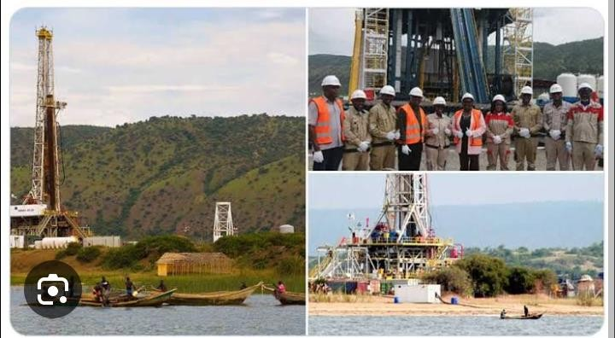

1. Identify the class and write the general molecular formula of the organicfamilytowhichthecomponents ofoilbelong (04scores)
2. Name and write the structural formula of the next two members of theorganicfamilynamedaftermethane (04scores)
3. Givingareasonforyouranswer,stateonemethodbywhichthecomponentsofcrudeoil.
4. KawukiEnock lives along the channels of a water body which supplies theentire village of Masajja with water. He has many cows which drink and movewithinthewaterbody.Hehasabig plantationofcropsnexttothewaterbodyonwhichheusesamassiveamountoffertilizestoensurethathegethighyields.He normally cools his machines in water and his wife earns a living by washingclothes daily for people in Masajja. The wife uses detergents and soap to washtheclothes.

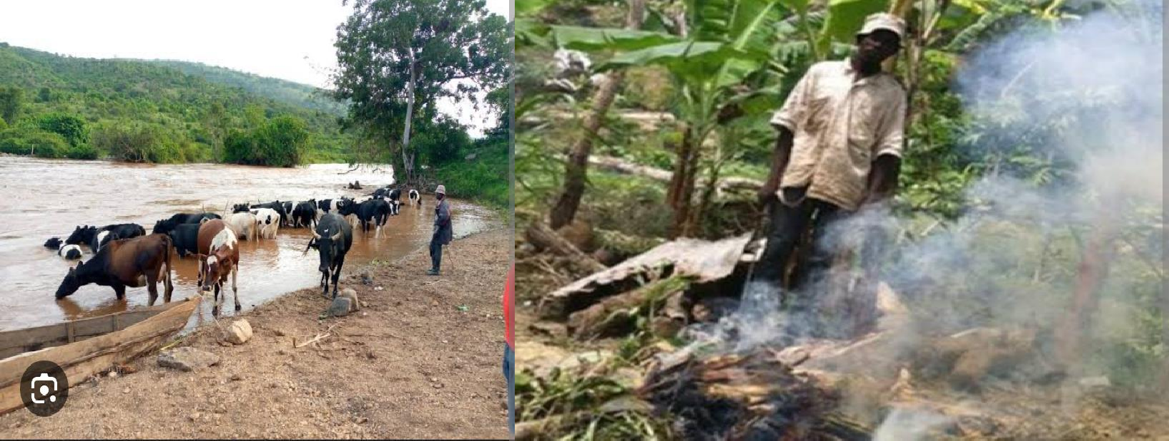

Write a piece of advise to KawukiEnock letting him know about the ways hisfamily and activities pollute the water body, the possible effects the pollutioncoulddotoMasajjaandhowhecanparticipateinsolvingtheproblemofwaterpollutioninthearea.

END